jGrasp Quickstart

The Basics
- jGrasp starts with three panels, showing the directories, your code, and any output messages.

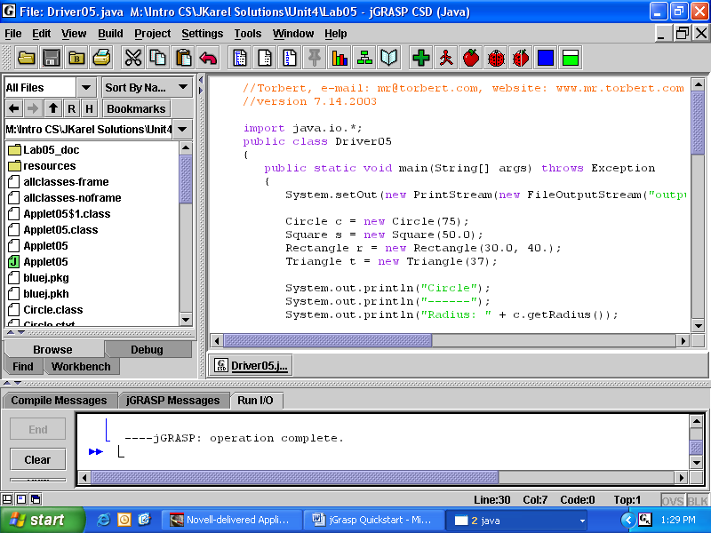

Generate CSD is in View. It also has a blue-and-white button.

Compile is in Build. Its button is the green cross.

Run is in Build, or a red running man button
2. If you use JAR files like edu.fcps.karel2_c.*, you will need to set the Classpath. Go to Settings | Compiler Settings | PATH/CLASSPATH | Workspace.
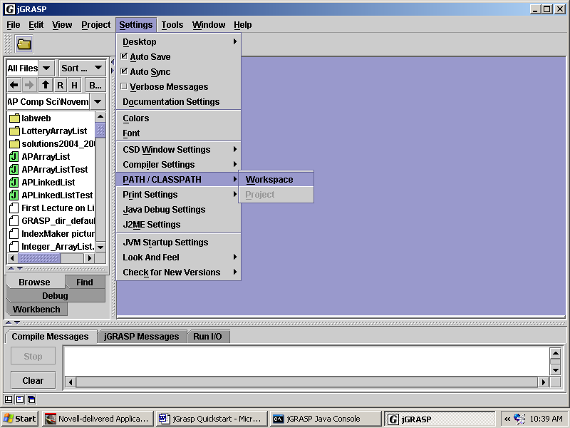

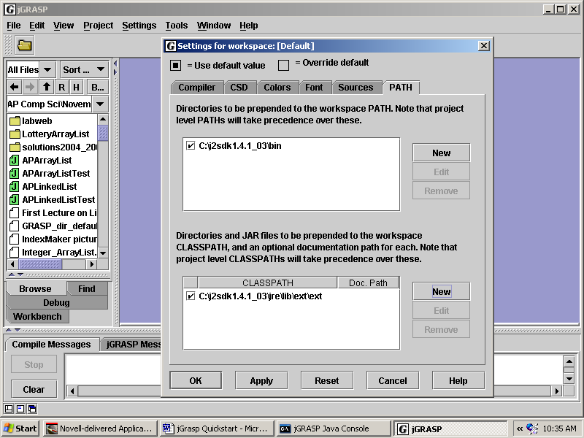
Go to the CLAPTHPATH tab, click on New, and Browse for the path to Java's c:\Program Files\Java\jdk1.5.0_15\jre\lib\ext folder. Click on Apply, OK.
More Advanced Features: Projects, Javadoc and UML

Projects help keep large applications organized. Projects are also nice because jGrasp can automatically create Javadoc and UML Diagrams.

3. Projects in jGrasp are easy to create, either before or after you write code. Go to Project, New. Then add the files you want. For today's demonstration, Open project Lab05.

4. To create a complete set of Javadoc documentation for the project, go to Project|Generate Documentation. You can look at it with Project | Show Documentation.

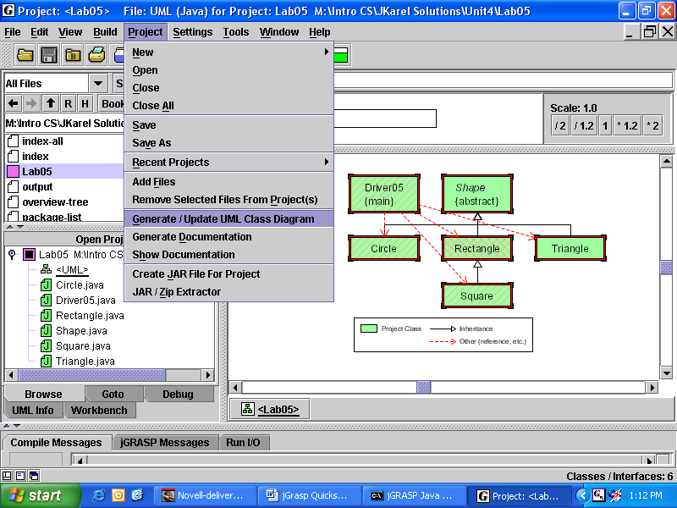
5. To create the UML Class Diagram, go to Project | Generate/Update UML Class Diagram. Shown below is a typical UML Diagram. You have lots of options to play with.

6. Advanced students may also want to try the object workbench. It is on a tab at the bottom of the File panel. To put an object on the workbench, right-click on its UML rectangle, and click on Create Instance.

7. JGrasp has a debugger, also on the tab at the bottom of the File panel.

